The Local 3D: Portfolio Blueprint
Nov 10, 2026 · @Arpit Singh

Thesis
The portfolio answers one question: for this visitor's intent and time budget, which evidence should they see, and in what order? The train is one way to show that answer, not the product.
\text{Route}(i, b) = \operatorname{order}\big(\{\, e \in E : \operatorname{relevance}(e, i) \ge \tau(b) \,\}\big)
E is all your evidence (projects and roles), i is the visitor's intent (skim, verify or explore), and b is their time budget. The threshold τ falls as b grows: a short budget keeps only flagship stops (Express), a long one keeps all of them (All stations).
This framing buys three things. The 3D line, a flat Classic view and a network map become interchangeable renderers of one route. The metaphor can change later without touching content. And every design choice gets a test: does it help a visitor reach evidence faster or judge it better?

Core model
Every metaphor term maps to one system concept, and only the third column is replaceable.
Metaphor | Abstract concept | How it shows up | Data field
Passenger | Visitor intent and time budget | Entry gate: Express, All stations or Map | intent, budget
Line | Ordering policy over evidence | Track path in 3D, card order in Classic view | route.order
Stop | One unit of evidence | Platform, station board, diorama | stops[]
Fast halt, slow stop | Priority tier | Express skips slow-only stops | tier
Ticket | A contract: claim, proof, next action | Pop-up ticket; front is the claim, back is the proof | claim, proof, links
Interchange | Relation between stops | Transfer lines on the map, skill filter | stack, domain
Timetable | Pacing | Dwell and travel lengths, snap points | pacing
Signage | Wayfinding and state feedback | Dot-matrix indicator, progress dots, deep links | derived
Sky | Progress without numbers | Dawn to night across the journey | derived
Terminus | Conversion | Contact ticket, résumé, repo links | cta
The data field is the source of truth. Renderers read it and never copy it, so a fix in one place updates the scene, the map and the Classic view together.

Invariants
Eight rules hold in every renderer. Break one and the metaphor has started to hide the work.
- One dataset, many renderers. No fact exists only in 3D. Anything a visitor learns in the scene is also in the Classic view.
- Two interactions to any stop. From anywhere, a visitor reaches any stop through the map, the progress dots, the keyboard or a deep link.
- A ticket stands alone. It holds a claim (one sentence), proof (a link, clip or metric) and a next action (repo, demo or case study).
- Motion carries information. If removing an animation loses nothing, remove it.
- Scroll is the only clock. Nothing auto-plays past a stop, and the visitor sets the pace.
- Degrade by layers. WebGL falls back to a poster scene, then to the Classic view, with identical content at every step.
- Honest evidence. Every claim links to something checkable, and no placeholder numbers ship.
- The ten-second contract. Within ten seconds a visitor knows who you are, what you do and how to reach you.

Experience blueprint
Seven upgrades turn the prototype into a recruiter-ready product, each aimed at one visitor need.
Prototype | Upgrade | Why it matters
One scroll path | Entry gate with three lines: Express (flagship stops, about a minute), All stations, and Network map | Serves different intents and time budgets from the first screen
Ticket shows text | Ticket v2: front is the claim, back is the proof, stub holds a QR code to the repo | Separates a two-second scan from a thirty-second read
Identical stations | One small diorama prop per stop, chosen from the project's domain | Makes each stop recognizable before its name is read
Progress is implicit | Dot-matrix indicator, progress dots and the sky cycle, plus a top-down Network map | Always answers where am I and what is left
Nothing is remembered | Ticket wallet: visitors keep tickets, and the terminus opens an email listing them | Turns browsing into a shortlist, with no backend
Interchange on hover | Skills drawn as transfer lines on the map; picking a skill filters stops | Lets an engineer navigate by technology, not by order
Desktop first | Swipe between stops, bottom-sheet tickets, stepped cuts when reduced motion is on | Keeps the journey usable on a phone and for motion-sensitive visitors

Ticket anatomy
- Front (two seconds): station board, claim, three stack tags, tier stamp.
- Back (thirty seconds): proof such as metrics, screenshots and an architecture sketch, plus role, period and the repo, demo and case-study actions.
- Stub: QR code to the repo, a serial number and a Keep ticket action for the wallet.

Entry gate
The gate asks where to, with Express, All stations and Map as three buttons. Links you control can preselect one: a résumé link opens Express, a portfolio link opens All stations. The wallet stays in the browser's local storage, so nothing leaves the visitor's device.

Architecture
Content feeds one framework-free core, and every renderer reads from that core. Nothing in core/ touches the DOM or three.js, so it stays testable and the renderers stay swappable.
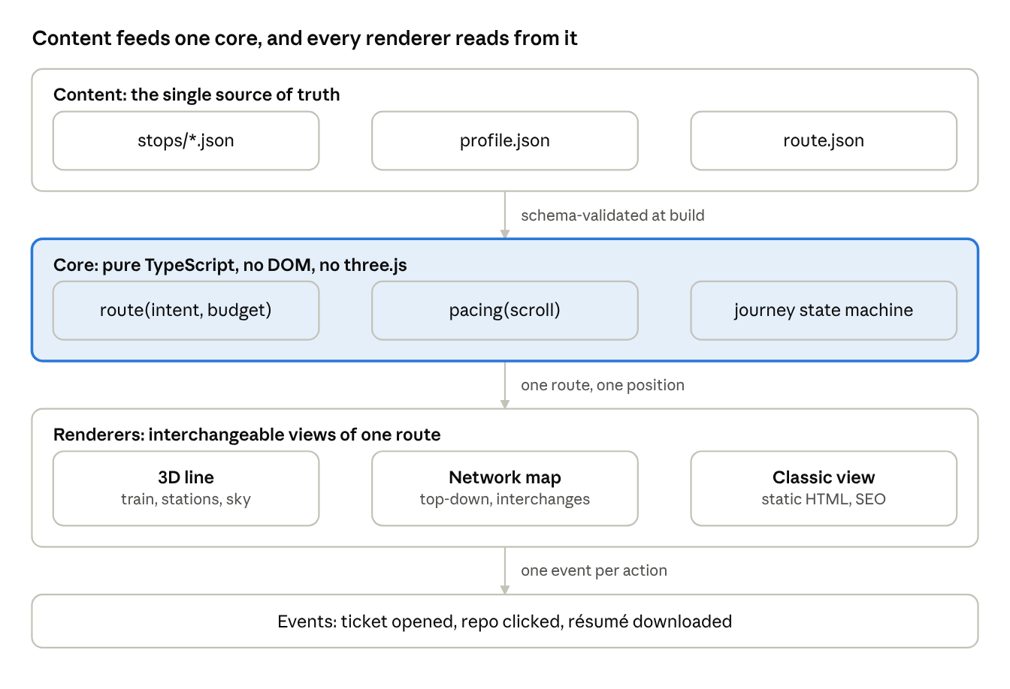
architecture · 3 layers, 3 renderers
Read it top to bottom: content is validated at build, the core turns a scroll position into a route position, and the renderers draw it.

Repo layout
portfolio/
├─ content/
│ ├─ stops/ # one file per stop (JSON or MDX)
│ ├─ profile.json # name, role, links, résumé path
│ └─ route.json # stop order, tiers, pacing weights
├─ src/
│ ├─ core/ # route(), pacing(), journey state machine
│ ├─ renderers/
│ │ ├─ scene3d/ # train, track, stations, sky, dioramas
│ │ ├─ map2d/ # network map, interchange lines
│ │ └─ classic/ # static, SEO-friendly page
│ ├─ ui/ # Gate, Ticket, Indicator, Wallet
│ └─ main.ts
├─ public/models/ # train.glb, props.glb (compressed)
├─ scripts/ # validate content, OG images, sitemap
└─ tests/ # unit (core) and end-to-end

Stop schema
Every stop is one record, and placeholders mark what you fill from GitHub.
{
"id": "slot-01",
"title": "TBD",
"oneLiner": "What it does, in one sentence",
"tier": "express",
"domain": "web",
"role": "solo",
"stack": ["TBD"],
"claim": "The result in one sentence, with a number if you have one",
"proof": { "metrics": [], "media": [], "architecture": "TBD" },
"links": { "repo": "TBD", "demo": "", "caseStudy": "" },
"period": { "start": "YYYY-MM", "end": "YYYY-MM" },
"station": "Kurla",
"prop": "TBD"
}
Allowed values: tier is express or local; domain is web, ai, systems, hardware or tools; role is solo, lead or contributor. The build fails if a required field is empty.

Pacing function
Scroll is the only clock. Let X be scroll distance in viewport heights; the core maps X to a route position s. It holds at stop k for that stop's dwell weight, then travels to the next stop over a fixed weight, easing in or out only at real halts. Express mode sets the dwell weight of local-only stops to zero, so the train passes through them. The function is pure, so it gets unit tests instead of screenshots.

Journey states
- Gate: the visitor picks Express, All stations or Map.
- Boarding: the train waits at the first stop with the hero card.
- Traveling: scroll moves the train between stops.
- Dwelling: the train holds at a stop and its ticket opens; scrolling on closes it and returns to Traveling.
- Terminus: the contact ticket and the wallet summary appear.
A map click, a progress dot or a deep link jumps straight to Dwelling at any stop.

3D art direction and budgets
Keep the look flat-shaded and baked. It reads well at 30 fps on a phone and stays inside the budgets below.
Element | Approach | Budget
Train | Three articulated cars sharing one mesh, baked ambient occlusion, emissive window map, wheel spin tied to speed, doors that open at a stop | 12k to 20k triangles, one 1024 px atlas
Track and city | Instanced sleepers, masts and buildings; ribbons for rails and ballast | Under 60 draw calls
Stations | A modular kit (platform, canopy, board) with baked light | Under 8k triangles each
Dioramas | One prop per stop, built from the project's domain | Under 3k triangles each
Sky | A gradient shader keyed to journey progress, with fog matching the horizon | No skybox texture
Lighting | One directional and one hemisphere light; bloom at night on the high tier only | No real-time shadows

Asset pipeline
- Model and bake in Blender, then export glTF.
- Compress with gltf-transform: Draco or Meshopt for geometry, KTX2 for textures, deduplicated meshes.
- Split into chunks (train and track first, each station's props on approach) so first paint never waits on dioramas.
- Check a build report that totals stay under the budgets in the acceptance table.

Camera rules
- Cap camera angular velocity so diagonal sweeps never exceed a gentle turn rate, and tune it on a phone.
- Keep the horizon level, with no roll.
- Ease the camera behind the train instead of rigidly attaching it.
- On reduced motion, replace sweeps with cuts between stops.

Content plan
Pick for coverage first, then for quality: nine project slots, each with a job, so the line shows range instead of nine variations of one skill. Fill the Repo column from your GitHub; every other cell is already decided.
Slot | Station | Tier | Job it must do | Repo | Media needed
1 | Kurla | Express | Flagship: your strongest end-to-end build | TBD | Cover image, 45 s clip, architecture sketch
2 | Ghatkopar | Express | Systems depth: networking, OS or low-level work | TBD | Diagram, terminal recording
3 | Mulund | Express | Data or AI: a model or pipeline with a measured result | TBD | Result chart, sample output
4 | Thane | Express | Product: something real people used | TBD | Screenshots, a user quote if you have one
5 | Dombivli | Express | Full stack: frontend, backend and deployment | TBD | Cover image, live link
6 | Sion | Local | Tooling: a utility you use yourself | TBD | Short clip
7 | Diva | Local | Hardware or graphics: physical or visual work | TBD | Photo or render
8 | Ulhasnagar | Local | Early work: shows how far you have come | TBD | Screenshot
9 | Ambernath | Local | Newest: what you are building now | TBD | Screenshot, status note
Kalyan Junction holds experience rather than a repo: your technical-lead role in the college Fintech committee. Dadar Junction is About, and Badlapur is the terminus with contact and résumé.

Selection rubric
Score each candidate repo out of 100. Feature it at 60 or more; below that, fix the README or drop it.
Criterion | What to check | Points
Clarity | README states the problem, the approach and shows a screenshot | 15
Runs fresh | Cloning it and running one command works | 15
Evidence | Live demo or a clip under a minute | 15
Fit | Matches the job the slot needs | 15
Role | Your part is clear, especially on team work | 10
Quality | Tests or CI, readable history, no secrets committed | 10
Recency | Touched in the last year, or clearly finished | 10
Originality | Not a tutorial clone | 10

Accessibility, performance and fallbacks
Every visitor lands on a working page: five tiers degrade the experience step by step while the content stays identical.
Tier | Condition | What changes
0 Full | WebGL works, motion allowed | Everything in this blueprint
1 Calm | Reduced motion is on | Cuts between stops, no camera sweeps, a static sky per stop
2 Light | Low-end GPU or slow device | Lower pixel ratio, fewer instances, 30 fps cap, no bloom
3 Classic | No WebGL, or context lost | Poster image plus the Classic view
4 Plain | No JavaScript | Classic view rendered to static HTML at build time

Accessibility
- A visually hidden list of stops mirrors the scene, with real headings, so screen readers and search engines see all the content.
- Keyboard: arrow keys move between stops, E picks Express, M opens the map, C opens the Classic view, and the ticket is a dialog that traps focus.
- An aria-live region announces Now at and Next as the indicator changes.
- Text on the dot-matrix board and tickets meets WCAG AA contrast.
- A pause control stops all ambient animation.

Performance habits
- Show a poster image first so the largest paint lands before the 3D loads.
- Pause rendering when the tab is hidden or the canvas is off screen.
- Lazy-load media per stop, and skip clips when the visitor has data saver on.
- Handle WebGL context loss by restoring the scene or dropping to tier 3.

Roadmap
The line is shippable after the third phase, and about five to six weeks of steady effort covers all six phases.
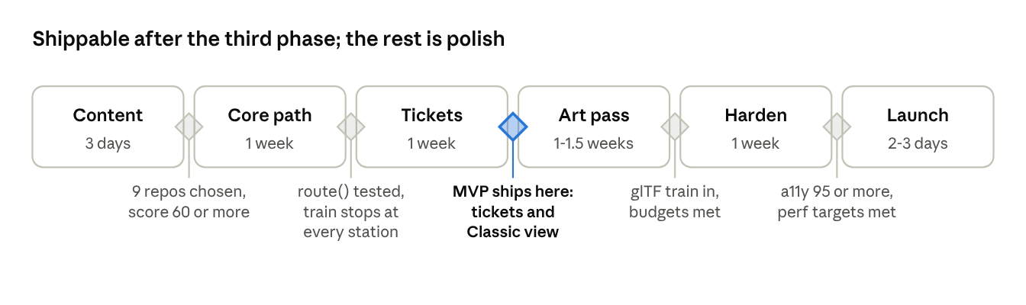
roadmap · 6 phases, 5 gates
If a gate fails, extend that phase instead of starting the next, and stretch the durations around exams.
- Content: choose the repos, score them with the rubric, fill the slots table.
- Core path: build route(), the pacing function and the journey states, with a placeholder train on the track.
- Tickets: drive stops and tickets from the data, then add the Classic view and deep links.
- Art pass: glTF train, station kit, dioramas, sky and lighting within budgets.
- Harden: accessibility, performance tiers, cross-browser tests and analytics.
- Launch: deploy, add social images and the résumé link, then share.

Acceptance criteria and metrics
The build is done when every row passes, and each target has a named way to measure it.
Area | Target | How to measure
Ten-second contract | 3 of 3 test visitors name who you are, what you do and how to contact you within 10 s | Watch three people, no hints
Largest contentful paint, mobile on 4G | 2.5 s or less | Lighthouse CI
Initial JavaScript | 350 KB gzip or less | Build size report
3D assets | 3.5 MB or less in total (models 1.5 MB, textures 2 MB) | Build size report
Frame rate | 55 fps or more on a laptop, 30 fps or more on a mid-range phone | Dev FPS meter on real devices
Lighthouse scores | Accessibility 95 or more; performance 85 or more on mobile, 95 or more on Classic | Lighthouse CI
Stop reachability | Every stop within 2 interactions | End-to-end test
Content parity | Every stop field appears in all three renderers | Unit test against the schema
Browser errors | Zero console errors in Chrome, Safari and Firefox | Playwright run
Conversion targets (tickets opened, repo clicks, résumé downloads) wait for two weeks of baseline data, so you set them from evidence instead of guessing.

Risks as derailments
The biggest risk is not technical: the metaphor can start to outweigh the work it carries.
Derailment | Early signal | Mitigation
Gimmick overshadows the work | Visitors mention the train but no project | A ticket appears within 2 s of each stop; test with strangers
Scope creep | Sound, weather and extra modes arrive before the MVP gate | Park them on a later list; nothing extra ships before the third gate
Weak repos | Several candidates score under 60 | Time-box a fix to two days per repo, or drop the slot
Heavy assets | Frame rate dips on a mid-range phone | Budgets checked in CI, tier 2 settings, lazy chunks
Motion discomfort | Visitors report dizziness or skip the scene | Angular-velocity cap, reduced-motion tier, a pause control
Invisible to search | Content exists only inside the canvas | Static Classic view and a hidden stop list, both built from the same data
Modeling bottleneck | The train model takes more than a week | Ship the primitive-built train from the prototype, upgrade later

Open decisions for Arpit
Nine choices are yours, and the first two unblock the rest.
- ☐ Pick nine repos using the rubric and fill the Repo column in the content plan
- ☐ Choose the framework: vanilla three.js, or React Three Fiber with a framework-free core (recommended, since you already know React)
- ☐ Pick the default entry line: Express or All stations
- ☐ Write the Kalyan Junction card on your Fintech committee role (one claim, one proof)
- ☐ Decide on sound: none, or off by default with a toggle
- ☐ Choose hosting and a domain: GitHub Pages, Vercel or Netlify
- ☐ Decide the train model source: build it in Blender, adapt a freely licensed model (check the license), or keep the primitive-built one
- ☐ Finalize a one-page résumé PDF for the terminus
- ☐ Choose analytics: a privacy-friendly tool or none

